EDA-TELECOM-DATA

|  |  |
| --- | --- |
| Total number of customers | 10000 |
| Total exited customers(churned) | 2037 |
| Total remaining customers(unchurned) | 7963 |

1) Univariant Analysis

**Count Plot**

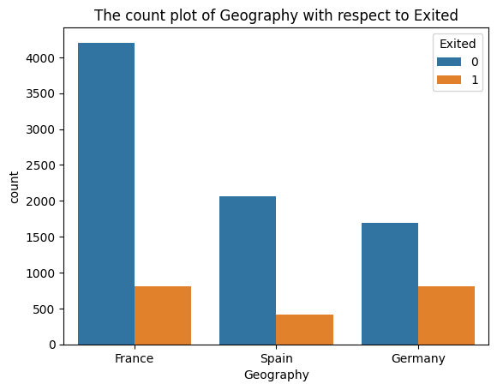

|  |  |
| --- | --- |
| Country | Exit Ratio |
| 1) France | 18% |
| 2) Spain | 20% |
| 3) Germany | 33% |

Exit Ratio = churn value/total.

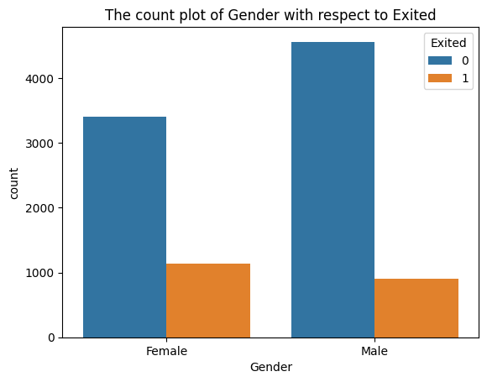

|  |  |
| --- | --- |
| Gender | Exit Ratio |
| Female | 24% |
| Male | 22% |

2) Bivariant Analysis

**Hist Plot**

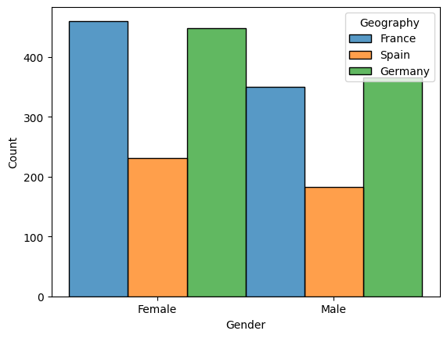

|  |  |  |
| --- | --- | --- |
| Country | Gender | Count |
| France | |  | | --- | | Female | | Male | | |  | | --- | | 500 | | 350 | |
| Spain | |  | | --- | | Female | | Male | | |  | | --- | | 250 | | 200 | |
| Germany | |  | | --- | | Female | | Male | | |  | | --- | | 450 | | 375 | |

3) Numerical Analysis

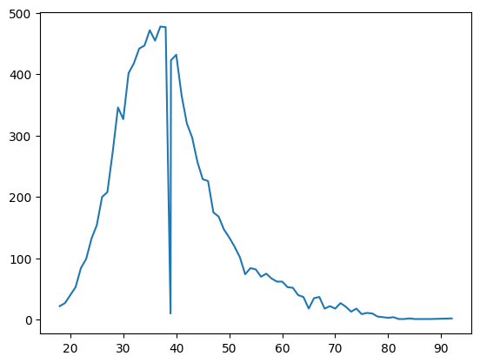

|  |  |
| --- | --- |
| Type Of Distribution: | Normal Distribution |
| Working members Age Group: | 30-50 |

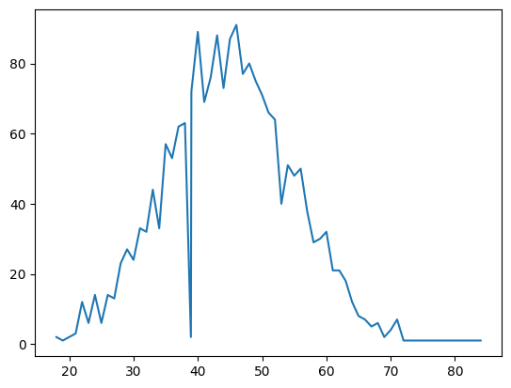

|  |  |
| --- | --- |
| Type Of Distribution: | Normal Distribution |
| Churned members Age Group: | 40-55 |

Classification

|  |  |
| --- | --- |
| Model Type | SVM |
| Features taken into consideration | Geography, Gender |
| Target taken into consideration | Exited (churned members) |
| Maximum model score obtained | 0.822 |

Conclusion

Most of the churned members are Females from France in the age group of 40-55.